LAB #7

Configure apps on Azure Kubernetes Service
In this exercise, you learn how to configure Kubernetes deployments with ConfigMaps for non-sensitive settings, Secrets for sensitive credentials, and PersistentVolumeClaims for persistent storage. You deploy a containerized API to Azure Kubernetes Service (AKS), configure it with various Kubernetes resources, and interact with it using a Python client application.
Tasks performed in this exercise:
- Download the project starter files
- Deploy resources to Azure (ACR, AKS cluster)
- Build and push a container image to Azure Container Registry
- Configure kubectl credentials for AKS cluster access
- Apply updated YAML files to AKS to create the pod and expose the API with a LoadBalancer
- Run the client app to test the API endpoints
- View API logs stored on persistent volume
- Clean up Azure resources
This exercise takes approximately 30 minutes to complete.
IMPORTANT: The persistent storage implementation in this exercise is for demonstration purposes only. For logging, production applications should use a centralized logging solution like Azure Monitor or Application Insights instead of storing logs on persistent volumes. If persistent storage is required, implement log rotation policies to prevent storage from filling up, which can cause container failures and pod evictions.
Important: Azure Container Registry task runs are temporarily paused from Azure free credits. This exercise requires a Pay-As-You-Go, or another paid plan.
Before you start
To complete the exercise, you need:
- An Azure subscription with the permissions to deploy the necessary Azure services. If you don't already have one, you can sign up for one.
- Visual Studio Code on one of the supported platforms.
- The latest version of the Azure CLI.
- The Kubernetes command-line tool, kubectl.
- Optional: Python 3.12 or greater.
Download project starter files and deploy Azure services
In this section you download the starter files for the console app and use a script to deploy the necessary services to your Azure subscription. The Azure Managed Redis deployment takes 5-10 minutes to complete.
- Open a browser and enter the following URL to download the starter file. The file will be saved in your default download location.
TypeCopy
https://github.com/MicrosoftLearning/mslearn-azure-ai/raw/main/downloads/python/aks-configure-python.zip
- Copy, or move, the file to a location in your system where you want to work on the project. Then unzip the file into a folder.
- Launch Visual Studio Code (VS Code) and select File > Open Folder… in the menu, then choose the folder containing the project files.
- The project contains deployment scripts for both Bash (azdeploy.sh) and PowerShell (azdeploy.ps1). Open the appropriate file for your environment and change the two values at the top of the script to meet your needs, then save your changes. Note: Do not change anything else in the script.
TypeCopy
$rg = "ResourceGroup1" # Resource Group name
$location = "<your-azure-region>" # Azure region for the resources
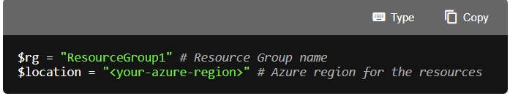
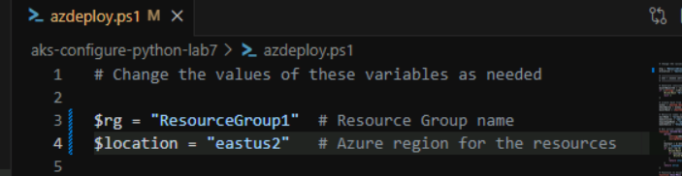

- In the menu bar select Terminal > New Terminal to open a terminal window in VS Code.
- Run the following command to login to your Azure account. Answer the prompts to select your Azure account and subscription for the exercise.
TypeCopy
az login
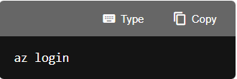
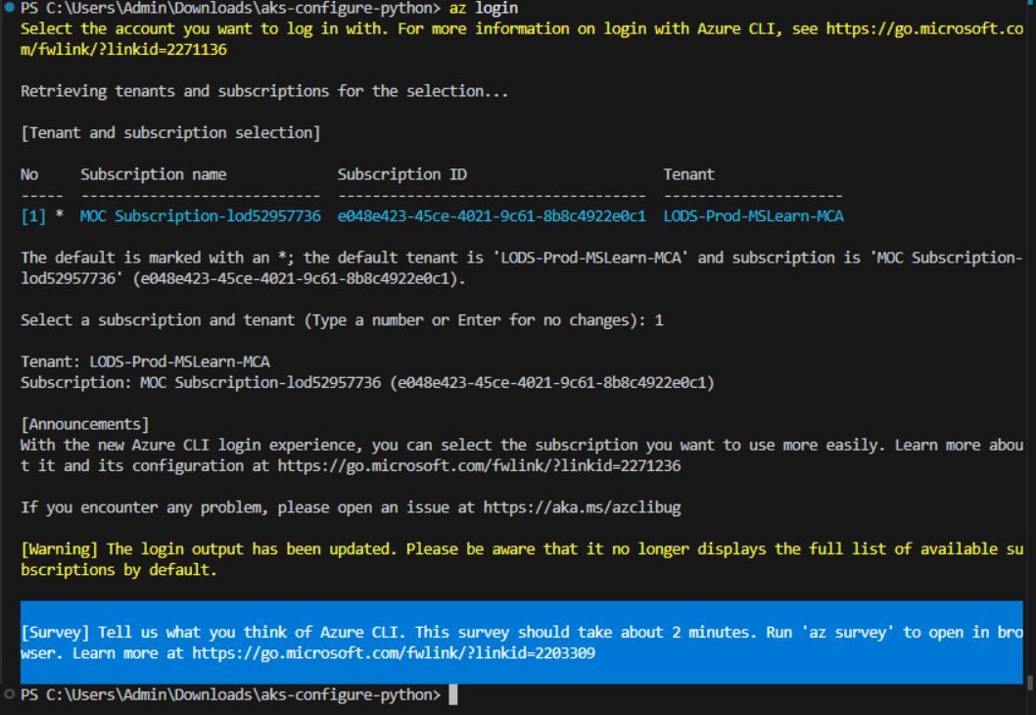
- Run the following commands to ensure your subscription has the necessary resource providers to install AKS and ACR. The Microsoft.Compute, Microsoft.Network, and Microsoft.Storage providers are dependencies of AKS that Azure usually registers automatically, but explicitly registering them avoids occasional cluster creation failures on new subscriptions.
TypeCopy
az provider register --namespace Microsoft.ContainerService
az provider register --namespace Microsoft.ContainerRegistry
az provider register --namespace Microsoft.Compute
az provider register --namespace Microsoft.Network
az provider register --namespace Microsoft.Storage

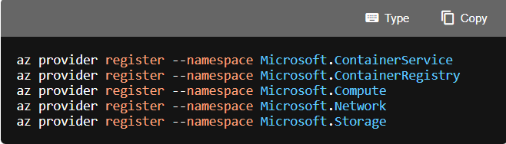
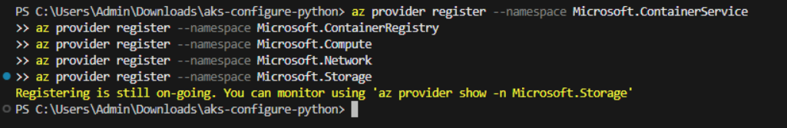
- Make sure you are in the root directory of the project and run the appropriate command in the terminal to launch the deployment script.
Bash
bashTypeCopy
bash azdeploy.sh
PowerShell
powershellTypeCopy
./azdeploy.ps1
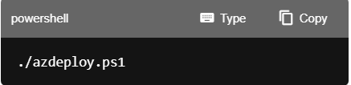
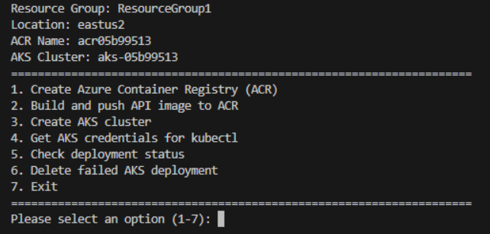
Note: If PowerShell blocks the script because it is not digitally signed, run the following command in the same terminal session, then run the deployment script again. This command changes the execution policy only for the current PowerShell process.
powershellTypeCopy
Set-ExecutionPolicy -Scope Process -ExecutionPolicy Bypass

Deploy resources to Azure
With the deployment script running, follow these steps to create the needed resources in Azure.
- After the model is deployed, enter 1 to launch Create Azure Container Registry (ACR). This creates the resource where the API container will be stored, and later pulled into the AKS resource.
When the operation is complete it will return the ACR endpoint. Copy the information, you need it later in the exercise.
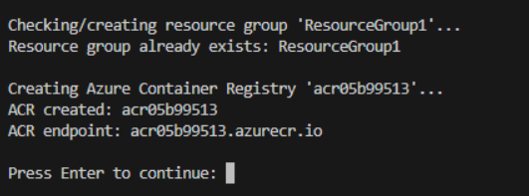
- After the ACR resource has been created, enter 2 to launch Build and push API image to ACR. This option uses ACR tasks to build the image and add it to the ACR repository. This operation can take 3-5 minutes to complete.
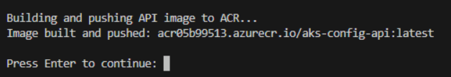
- After the image has been built and pushed to ACR, enter 3 to launch the Create AKS cluster option. This creates the AKS resource configured with a managed identity, gives the service permission to pull images from the ACR resource, and assigns the needed RBAC role to write to the persistent storage. This operation can take 5-10 minutes to complete.
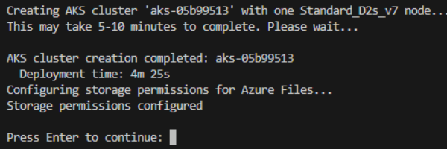
- After the AKS cluster deployment has completed, enter 4 to launch the Get AKS credentials for kubectl option. This uses the az aks get-credentials command to retrieve credentials and configure kubectl. 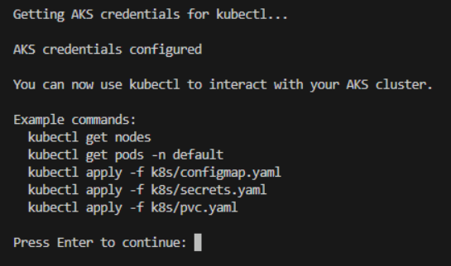
- After the credentials have been configured, enter 5 to launch the Check deployment stats option. This option reports if each of the resources have been successfully deployed.
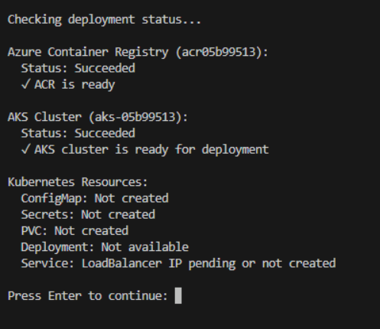
If all of the services return a successful message, enter 6 to exit the deployment script.
Next, you complete the YAML files necessary to deploy the API to AKS.
Complete the YAML deployment files and deploy to AKS
In this section you complete YAML files, located in the k8s folder, needed to configure Kubernetes deployments with persistent storage, and store sensitive and non-sensitive settings.
Complete the ConfigMap YAML file
ConfigMaps store non-sensitive configuration data as key-value pairs that can be consumed by pods. In this section, you create a ConfigMap to store application settings like the student name, API version, and log path.
- Open the k8s/configmap.yaml file and add the following code to the file. You can update the value for STUDENT_NAME with your name if you want to.
ymlTypeCopy
apiVersion: v1
kind: ConfigMap
metadata:
name: api-config
labels:
app: aks-config-api # Label for the AKS configuration API
data:
# Store non-sensitive configuration values
STUDENT_NAME: "YourNameHere"
API_VERSION: "1.0.0"
LOG_PATH: "/var/log/api" # Path for API logs
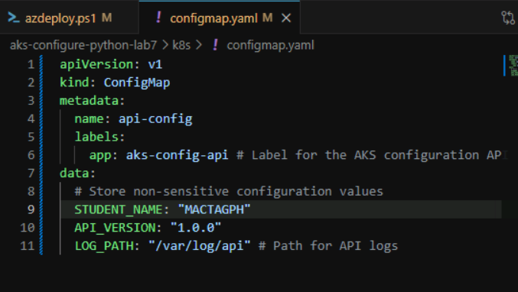
- Review the comments in the code, then save your changes.
Complete the Secrets YAML file
Secrets store sensitive information like passwords, tokens, and keys in a base64-encoded format. In this section, you create a Secret to store sensitive credentials that the API will access at runtime.
- Open the k8s/secrets.yaml file and add the following code to the file.
ymlTypeCopy
apiVersion: v1
kind: Secret
metadata:
name: api-secrets
labels:
app: aks-config-api
type: Opaque
stringData:
# Store sensitive credentials as base64-encoded values
secret-endpoint: "SecretEndpointValue"
secret-access-key: "SecretAccessKey123456"
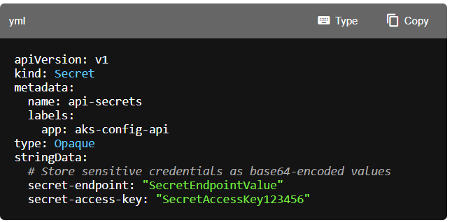
- Take a few minutes to review the comments in the code, then save your changes.
Complete the PVC YAML file
A PersistentVolumeClaim (PVC) requests storage resources from Azure that can be mounted to pods. In this section, you create a PVC that uses Azure Disk storage to persist API log files across pod restarts.
- Open the k8s/pvc.yaml file and add the following code to the file.
ymlTypeCopy
apiVersion: v1
kind: PersistentVolumeClaim
metadata:
name: api-logs-pvc
labels:
app: aks-config-api # Label for the AKS configuration API
spec:
accessModes:
- ReadWriteOnce # Allow single pod to mount volume for read/write
resources:
requests:
storage: 1Gi # Request minimum Azure Disk size
storageClassName: managed-csi # Use Azure Disk CSI driver (default)
volumeMode: Filesystem # Default mode
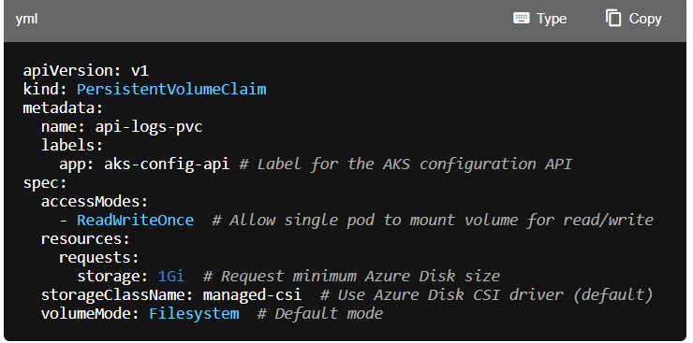
- Take a few minutes to review the comments in the code, then save your changes.
Update the Deployment YAML file
The deployment manifest is already partially configured with environment variables, volume mounts, and probes. You just need to update the container image reference with your specific ACR endpoint.
- Open the k8s/deployment.yaml file and locate the image: <YOUR_ACR_ENDPOINT>/aks-config-api:latest line.
- Replace <YOUR_ACR_ENDPOINT> with the value you recorded earlier in the exercise.
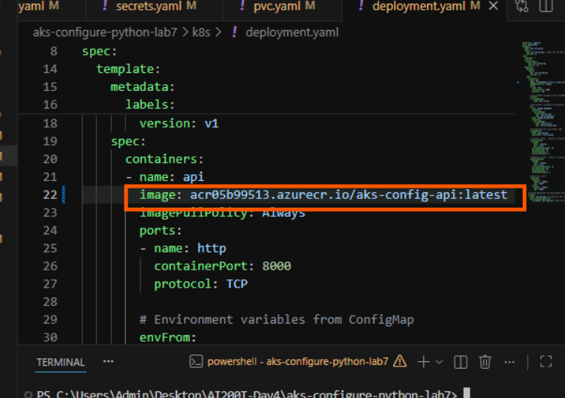
- Take a few minutes to review the comments in the code, then save your changes.
Apply the manifests to AKS
In this section you apply the manifests to AKS. The following steps are performed in the VS Code terminal. Ensure you are in the root of the project before running the commands.
- Run the following command to apply the ConfigMap.
TypeCopy
kubectl apply -f k8s/configmap.yaml
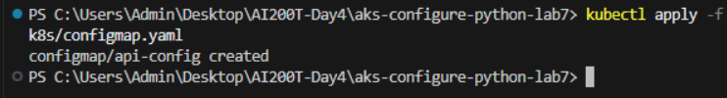
- Run the following command to apply the Secrets.
TypeCopy
kubectl apply -f k8s/secrets.yaml
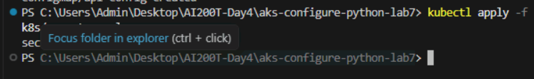
- Run the following command to apply the PersistentVolumeClaim.
TypeCopy
kubectl apply -f k8s/pvc.yaml
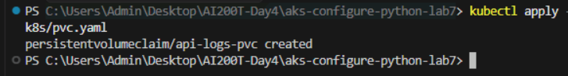
- Run the following command to apply the Deployment.
TypeCopy
kubectl apply -f k8s/deployment.yaml
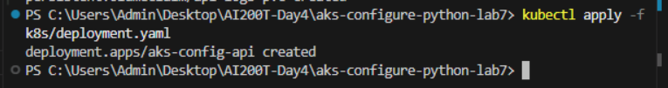
- Run the following command to create the Service.
TypeCopy
kubectl apply -f k8s/service.yaml
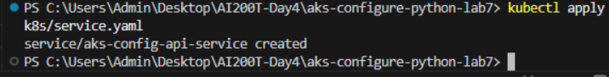
- After you create the Service it can take a few minutes for the deployment to complete. The following command will monitor the service and update the external IP address of the pod when it's available. Note the external IP address, you need it later in the exercise. Enter ctrl + c to exit the command after the IP address appears.
TypeCopy
kubectl get svc aks-config-api-service -w
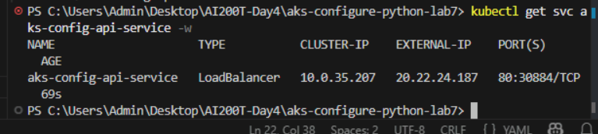

PS C:\Users\Admin\Desktop\AI200T-Day4\aks-configure-python-lab7> kubectl get svc aks-config-api-service -w
NAME TYPE CLUSTER-IP EXTERNAL-IP PORT(S) AGE
aks-config-api-service LoadBalancer 10.0.35.207 20.22.24.187 80:30884/TCP 69s

Run the client app
In this section, you configure the Python environment and then perform operations on the API using the client app
Configure the Python environment
In this section, you create the Python environment and install the dependencies.
- Ensure you are in the client folder of the project in the terminal.
- Run the following command in the VS Code terminal to create the Python environment.
TypeCopy
python -m venv .venv
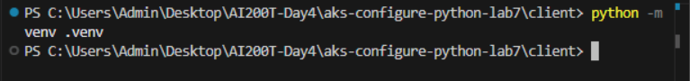
- Run the following command to activate the Python environment. Note: On Linux/macOS, use the Bash command. On Windows, use the PowerShell command. If using Git Bash on Windows, use source .venv/Scripts/activate.
Bash
bashTypeCopy
source .venv/bin/activate
PowerShell
powershellTypeCopy
.\.venv\Scripts\Activate.ps1
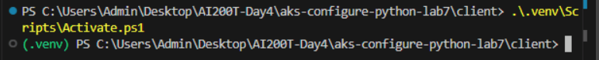
- Run the following command in the VS Code terminal to install the dependencies.
TypeCopy
pip install -r requirements.txt
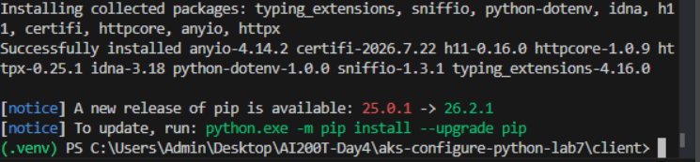
- Create a .env file in the client directory and add the following code. Replace <API_IP_address> with the value you copied earlier in the exercise.
TypeCopy
# API endpoint - update this with the external IP from the LoadBalancer service
# Get the IP with: kubectl get services
API_ENDPOINT=http://<API_IP_address>

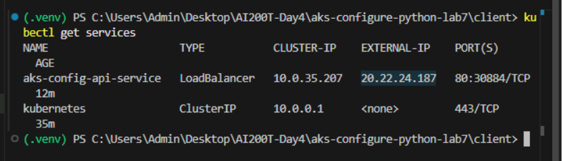
Perform operations with the app
With the Python environment configured and dependencies installed, you can now run the client application to test the deployed API. The API logs all operations to the persistent volume, and the client provides a menu-driven interface to interact with various endpoints.
- Run the following command in the terminal to start the console app. Refer to the commands from earlier in the exercise to activate the environment, if needed, before running the command.
TypeCopy
python main.py
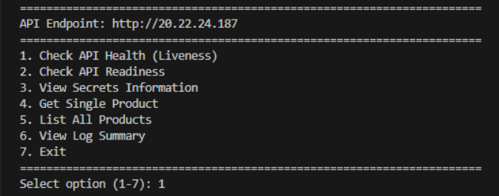
- Enter 1 to start the Check API Health (Liveness) option. This verifies that the API container is running and responds to health checks, which is the same endpoint used by the Kubernetes liveness probe. Note the information it returns contains the non-sensitive student name set in ConfigMap.
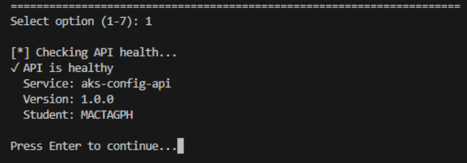
- Enter 2 to start the Check API Readiness (Foundry Connectivity) option. This confirms the API can successfully connect to the Foundry model endpoint and is ready to process inference requests.
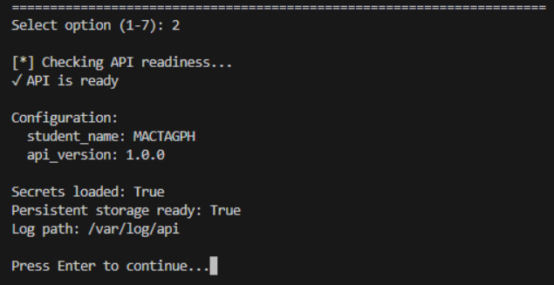
- Enter 3 to start the View Secrets Information option. This functionality exists only so you can confirm your secrets were set in the pod and is for demonstration purposes only. In the output you can view information about the secrets, the output is masked.
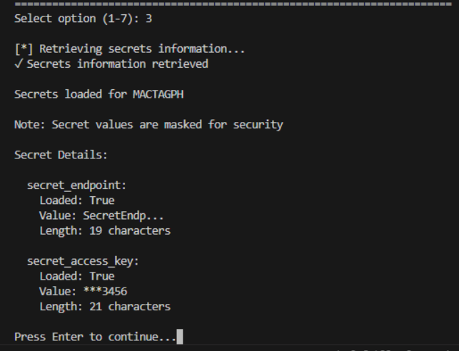
- Enter 5 to start the List All Products option. This displays the mock data included in the API.
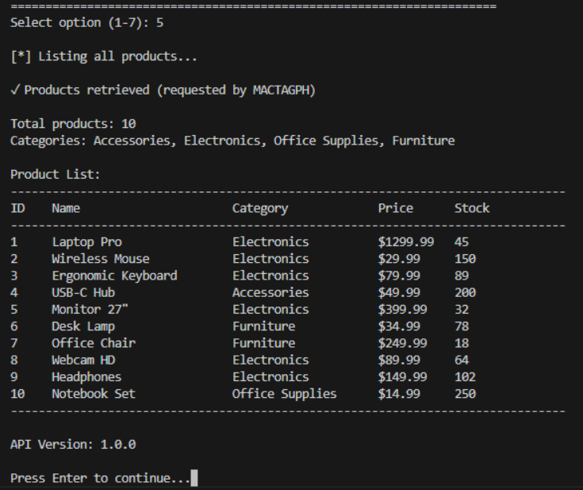
- Now that the API has logged operations for several different endpoints, it's time to view the logs. Enter 6 to start the View Log Summary option and see a summary of the different operations. Note the total number of requests, and the requests to the /readyz and /healthz endpoints. Those two operations are executing automatically based on the schedule set in the deployment.yaml file.
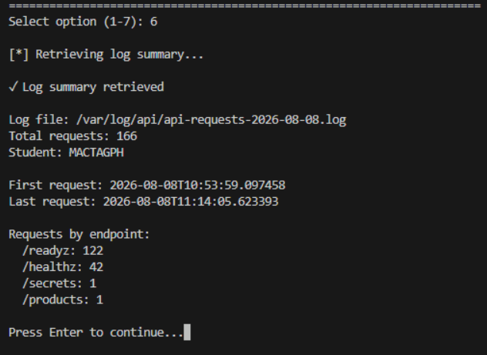
- You can continue to generate log information and when you're finished enter 7 to exit the app.
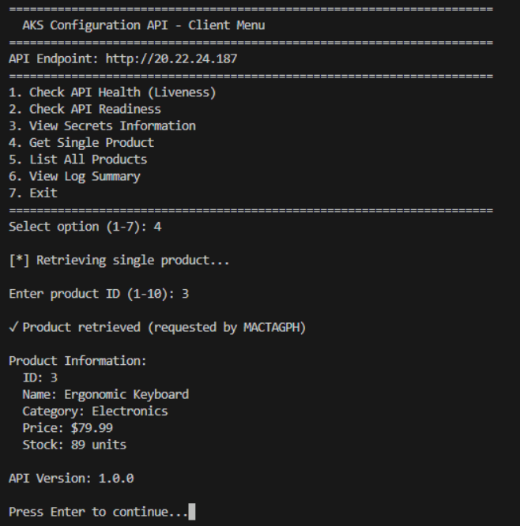
Clean up resources
Now that you finished the exercise, you should delete the cloud resources you created to avoid unnecessary resource usage.
- Run the following command in the VS Code terminal to delete the resource group, and all resources in the group. Replace \ with the name you choose earlier in the exercise. The command will launch a background task in Azure to delete the resource group.
TypeCopy
az group delete --name <rg-name> --no-wait --yes
CAUTION: Deleting a resource group deletes all resources contained within it. If you chose an existing resource group for this exercise, any existing resources outside the scope of this exercise will also be deleted.
Troubleshooting
If you encounter issues while completing this exercise, try the following troubleshooting steps:
Check deployment status with the deployment script
- Run the deployment script and select option 5. Check deployment status to verify the state of all deployed resources.
- This command checks:
  - ACR provisioning state and readiness
  - AKS cluster provisioning state
  - Kubernetes resources (ConfigMap, Secrets, PVC, Deployment availability, Service LoadBalancer IP)
- Use this output to identify which component may be causing issues.
Verify YAML file completeness
- Ensure all YAML content was added correctly to configmap.yaml, secrets.yaml, and pvc.yaml and that indentation is correct.
- Confirm the ACR endpoint was properly updated in deployment.yaml (replace <YOUR_ACR_ENDPOINT> with your actual ACR endpoint).
- If you make changes to any YAML file after initial deployment, reapply the file with kubectl apply -f k8s/\.yaml.
- After updating ConfigMap or Secret files, perform a rolling restart to reload the configuration: kubectl rollout restart deployment aks-config-api.
Verify client configuration
- Ensure you've created a .env file in the client folder with API_ENDPOINT set to the LoadBalancer's external IP (for example, http://20.xxx.xxx.xxx).
- Verify you can reach the API endpoint by running curl http://\/healthz from the terminal.
Check Python environment and dependencies
- Confirm the virtual environment is activated before running the client app.
- Verify that all packages from requirements.txt were installed successfully by running pip list.
- Ensure you're running the client from the client directory.

Congratulations
You have successfully completed this lab. Click End to mark the lab as Complete.

